**Driver Drowsiness Detection and Alerting System**

**Abstract-**

Driver drowsiness detection is a system that uses various sensors and algorithms to detect when a driver is becoming fatigued or drowsy. This can be done through monitoring eye movements, facial expressions, and head position, as well as analyzing driving patterns such as sudden lane changes or prolonged periods of inactivity on the steering wheel. The system can then alert the driver to take a break or pull over to rest, potentially preventing accidents caused by drowsy driving. It can also be used in commercial vehicles for safety of drivers and other people on the road. Accidents in the present day are increasingly being caused by this consisting of ocular fatigue. These characteristics show that the driver's condition is not right. For the purpose of detecting sleepiness, the ratio of distances between the horizontal and vertical eye landmarks is calculated using the EAR (Eye Aspect Ratio).

The eye-opening suggested method calculates the landmark since the landmarks are identified precisely enough to do so. Determines the eye aspect ratio (EAR), a single scalar quantity that characterizes the opening of the eyes in each frame, and extracts it. Finally, an SVM classifier developed by Haar Casacde recognizes eye blinks as a pattern of EAR values. However, both driver fatigue and distraction may result in slower response times, reduced driving efficiency, and a higher risk of being involved in an accident. The output is delivered to the detection system, and the alert will be activated, if the driver's degree of fatigue and the estimated amount of sleepiness are determined. There are many methods to spot drowsy driving, yet there aren't many signs of it. The driver could not keep his eyes open while sleeping. The last few seconds drivers eye might be closed and eyes are being detected that feeling drowsiness/sleepy.

The true number of accidents brought on by driver fatigue is difficult to ascertain because it is frequently underreported. The driver typically doesn't notice the small change from being tired to nodding off. This explains why it is critical to continue research in this area with the goal of reducing the frequency of driver drowsy accidents and motivating for a driver sleepiness detection system.

**INTRODUCTION**

Driver drowsiness rank among the most common reasons for collisions more people worldwide pass away as a result of these accidents every year this is the number of collisions attributed to driver fatigue and sleepiness per the newspaper thus traffic safety will increase drowsy driving detection technology in cars can help avoid collisions and save the lives of drivers who are starting to nod off in this study drowsy driving is detected using computer vision technology has improved transportation options due to its constant developments and creativity our reliance on it has grown significantly recently it has had a huge impact on our lives.

A technique called driver drowsiness detection is used in cars to prevent accidents when drivers become drowsy. According to various statistics, tiredness is a factor in about 20% of all traffic injuries and can reach 50% on some highways. The primary factor in a considerable proportion of traffic accidents is driver tiredness. According to recent data, there are around 1,300 fatalities and 75,000 injuries yearly attributed to being overtired. The most significant issue with accident prevention systems is trying to build technology that detect or prevent tiredness. Techniques to mitigate its effects must be developed because of the threat that sleepiness poses on the road. Driver inattention, tiredness, and distraction while driving can all lead to driver carelessness. Driver interruption happens when something or someone diverts the driver's focus from the task of driving. Driver drowsiness, in contrast to driver tiredness, does not require a trigger event and is instead characterized by a gradual loss of attention to the demands of the road and the surrounding traffic.

However, both driver fatigue and distraction may result in slower response times, reduced driving efficiency, and a higher risk of being involved in an accident. The output is delivered to the detection system, and the alert will be activated, if the driver's degree of fatigue and the estimated amount of sleepiness are determined.

The majority of the distinctive features on a photograph of a human face, such as eye corners and eyelids, can now be detected by trustworthy real-time facial landmark detectors. Most contemporary landmark detectors treat the problem as a regression problem, learning a mapping from an image into landmark locations or other landmark parametrization. These contemporary landmark detectors were developed using "in-the-wild datasets," making them resistant to changes in lighting, different face expressions, and mild non-frontal head rotations. Modern detectors often have an average landmark localization error of less than 5% of intraocular distance. Modern methods are used to do even more super-real-time activities.

As a result, we outline a simple but effective technique for identifying eye blinks that makes use of a recent facial landmark detector. The landmarks are used to generate a single scalar variable that represents the degree of the eye opening.

**OBJECTIVES**

Design and development of the driver-drowsiness detection system to warn drivers who are feeling tired while operating a vehicle The objective of this project is to develop a camera-based monitoring system that can detect indicators of intoxication in drivers of moving cars and alert the driver. We looked at previous studies on the topic of drowsy driving detection, examined the symptoms of tiredness in drivers, and established the technological requirements and algorithms required to analyze indications of the state of drowsiness.

We identify two alternative methods for addressing the tiredness detection issue:

1. The first one focuses on utilizing deep learning to examine a collection of driver-related photos.
2. The dlib is used to estimate the position of 68 coordinates (x, y) that map the facial points on a person's face.

It is a face detector for a landmark that makes use of trained models. In order to determine the distance between two locations, we apply the formula d= sqrt((x2-x1)2 + (y2-y1)2). Euclidean distance

**Equations**

The eye landmarks are identified for each frame of the video. Calculated is the eye aspect ratio (EAR), which compares the eye's height and breadth.



And to calculate the distance between two points,



**SYSTEM DESIGN**

A camera records the driver's face while they are driving and turns it into a video feed. The programme then examines the video to look for signs of exhaustion and sleepiness while also measuring the amount of drowsiness. The driver's facial tracking, degree of fatigue, and speed are the main factors that should be examined at this point. And identification of critical facial areas based on eye closure.

The system is set up to constantly monitor the driver's face and eyes. If the established alertness levels are shown to be violated or defaulted, an appropriate alarm is sounded, and suitable action is then taken to avoid any deaths. As can be seen, the camera is used to continually watch the driver's face. If the system in the dashboard detects sleepiness or exhaustion, it will provide a voice alert warning to the driver**.**

A package of test data The iBUG-300w Dataset, which includes 300 indoor and equivalent numbers of outdoor photos, is the experimental dataset utilized in our study. The collection includes many different types of identities, face sizes, lighting, poses, etc. Beyond the typical neutral grin, the photos in the 300-W collection also depict other emotions like surprise or scream. The image was annotated using 68-point markup.

The system's approach states that the driver is feeling weary if the eyes are closed prolonged for much time (greater than the predetermined threshold number of frames). From this point on, one of these exceptional instances occurs, and the related outcome occurs. In the scenario where the face is perfectly oriented and there are no wearable obstructions present, the accuracy as assessed during the performance analysis phase is virtually determined to be 100%. When there is an obstruction, accuracy somewhat decreases (e.g., Hat). For the best effects, ambient lighting conditions are crucial. If the user closes their eyes, a verbal alarm is produced, but the system responds incorrectly and out of sync. Therefore, it is best to avoid such a circumstance to avoid any inconsistencies.

**CLASSIFICATION**

Generally speaking, it is untrue that a low EAR value indicates that someone is blinking. The EAR may have a low value if a subject intentionally closes their eyes for an extended period of time, or when the EAR finds a momentary different chanes of the landmarks. Therefore, we developed a classifier that uses the frame's wider temporal window as input. We conducted experiments on 30 fps movies and observed that detecting a blink for a frame when an eye is blinking the most can be greatly influenced by about 6 frames. As a result, each frames are 13d feature is created by sequence the EAR of its 6 closest neighbours.

**Haar Cascades**

The Haar cascade is an object detection method used to identify objects in images or video streams. It is based on the Haar wavelet, a mathematical tool used in image processing. The Haar cascade algorithm starts by analyzing the image using a set of simple features called Haar-like features. These features are calculated by comparing the sum of pixel intensity in rectangular regions of the image.

The algorithm then uses a machine learning classifier, such as a cascade of boosted classifiers using the Ad boost algorithm, to determine if the detected features are indicative of an object of interest. The classifier is trained on a set of positive and negative images, where positive images contain the object of interest, and negative images do not.

The Haar cascade algorithm is commonly used for object detection in images and video streams, particularly for face detection and it's available as pre-trained models in dlib. It is considered as one of the fastest and robust method for object detection. The algorithm is efficient in terms of processing time and memory usage, making it suitable for real-time applications.

haar feature collecting, cascade, Ad boost training, and integral image generation classifiers. It is renowned for its capacity to identify bodily parts. as well as faces in images which we have utilized to detect faces from frames.

A classifier is employed in a scanning-window method during testing. With the exception of the first and last frames of a video series, the 13-dimensional feature calculated and categorized using EAR SVM is utilized as a per-trained model for the project.

**Proposed Method**

Dlib is a C++ toolkit for machine learning and computer vision that can be used for driver drowsiness detection. One way to use dlib for this task is by using its facial landmark detection capabilities to track the position and movement of the driver's eyes, mouth, and other facial features.

The system can then analyze these features to determine if the driver is becoming drowsy or fatigued.

Dlib also has pre-trained models for facial detection, alignment and recognition which can be used in driver drowsiness detection system. The system can detect the eyes and mouth using these pre-trained models and can analyze them to check if the driver is drowsy or not.

First, using facial landmark detection, the face may be located in the picture/Video. Then, crucial facial traits are found using shape prediction techniques. OpenCV's built-in HAAR cascades, which have already been trained, do face detection. Using a facial landmark detector that is pre-trained and part of the dlib library, In the following stage, the location of 68 (x, y)-coordinates that correspond to facial structures is calculated. It is also trained on the iBUG 300-W dataset. The ratio of distances between the horizontal and vertical ocular landmarks is used to compute the EAR in order to identify tiredness. The distance will then be measured against a threshold value. When the motorist starts to drowse or yawn, an appropriate/loud voice notifies them.

A human eye blinks is a quick shutting and reopening motion. Every person blinks in a somewhat unique pattern. The pattern varies in blink duration, degree of eye squeezing, and speed of opening and closing. It takes an eye between 100 and 400 milliseconds to blink. We advise locating the outlines of the eyes using state-of-the-art facial landmark detectors. The eye aspect ratio (EAR), a modest approximation of the eye opening state, is calculated using the landmarks visible in the picture. When trained as EAR, a classifier that takes into account a larger temporal window of a frame would not always recognize eye blinks reliably for every frame.

**EVALUATION OF THE DRIVER'S FATIGUE STATE**

This section goes over how to analyses the driver's facial key. points and from facial key points detecting the eyes to measure the EAR and eye closure.

1. **Determination of facial key points**

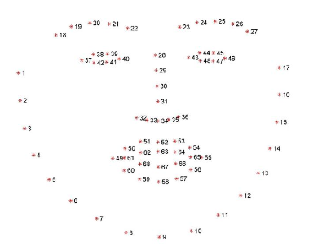

We must first determine where the human face is situated within the overall picture. The face detector is a technique that finds a human face in an image and outputs a bounding box.

After determining the location of the face in the image, we must then identify the smaller facial characteristics, such as the lips and eyebrows. We are informed of all the necessary human face characteristics by the facial landmark detection.

1. **The state recognition for eye**

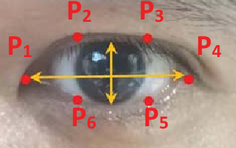

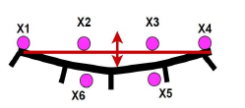

|  |  |  |  |
| --- | --- | --- | --- |
| **Name** | **Position** | **i** | **j** |
| **Left eye** | *Upper left vertex of the region  *Lower right vertex of the region | 18  22 | 37  40 |
| **Right eye** | *Upper left vertex of the region  *Lower right vertex of the region | 23  27 | 43  46 |

The above table illustrates how to detect an eye using 68 coordinates. The left and right eye points are 37–42 and 43–48, respectively.

**SYSTEM ARCHITECTURE**

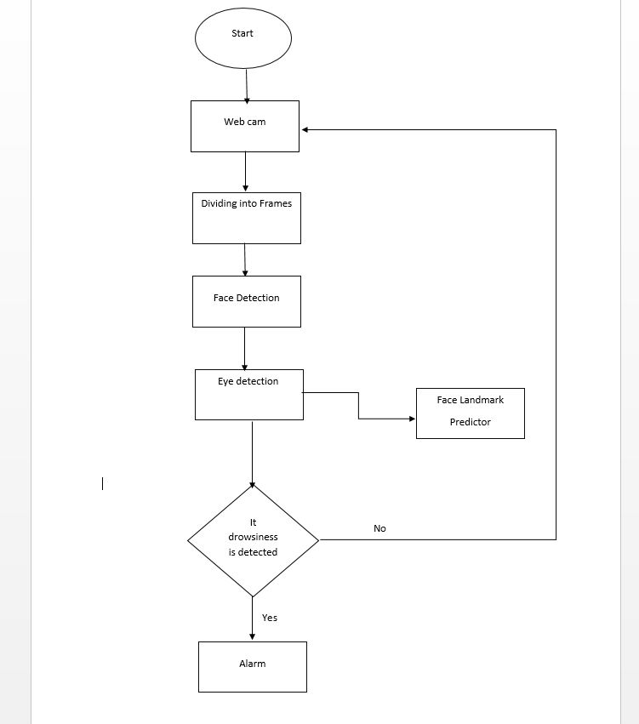

This includes many system implementation considerations, such as the functional specifications, the techniques, and tools selected for system testing across distinct research contexts. The image is separated into sub regions, with each sub region being evaluated to see if it contains a face or not. By using this approach, processing just the sub regions that include faces is speed it up.

The webcam is initially turned on, and the live video capture is split into frames. From there, faces are discovered, and from faces, eyes are detected using face landmark predictor. From there, we determine whether the driver is feeling sleepy or not, and if so, an alarm warns the driver.

**Performance Analysis**

To get the desired outcomes, several photos were captured, and their accuracy in sleepiness (as determined by the EAR calculation) was examined.

**Face improperly aligned**

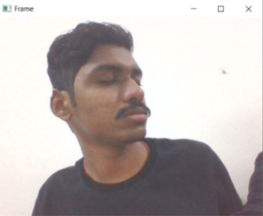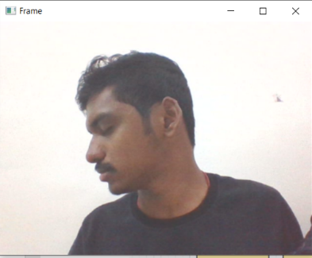

Top of Form

**Face properly aligned and eyes closed**

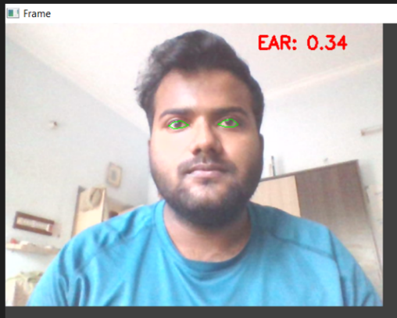

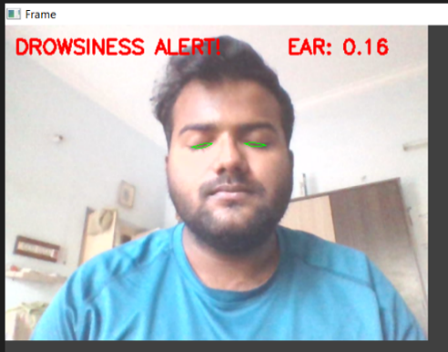

**LIMITATIONS**

Experiments don't take into account camera functions like auto-zoom and auto-rotation adjustments. Once the eyes have been located, automated zooming in will assist to improve accuracy. When the driver is not looking directly at the camera, the accuracy of eye recognition decreases.

False alarms: The system may produce false alarms if it is unable to accurately distinguish between drowsy and alert states, or if it is triggered by non-drowsy factors such as a driver blinking or looking away from the road.

Lighting conditions: Some systems may have difficulty detecting drowsiness in low light conditions, or if the driver is wearing sunglasses or a hat.

Privacy concerns: Some people may be uncomfortable with the idea of being monitored while they drive, and may not want to use a system that tracks their facial expressions and eye movements.

Complexity: Developing a robust driver drowsiness detection system that can accurately detect drowsy states in a wide range of driving conditions is a complex task that requires sophisticated algorithms and sensors.

Human Error: If the driver doesn't want to follow the system's alert or if the driver is not trained properly for the system, the system's limitation is the human error.

Limited to specific populations: Some systems are designed and tested only with specific populations, such as young and healthy drivers, and may not work as well for older drivers or those with medical conditions that affect their ability to stay alert.

Cost: Developing and implementing a driver drowsiness detection system can be expensive, and it may not be feasible for all vehicles or drivers.

**CONCLUSION AND FUTURE SCOPE**

The model may be progressively enhanced by incorporating other factors like blink rate, yawning, automobile condition, etc. Utilizing all of these factors can enhance. In order to further the project, we intend to include a sensor that monitors heart rate. may also be utilized in software that keeps a user from falling asleep accuracy is really high to stop accidents brought on by drivers' abrupt heart attacks. When a user is dozing off, streaming services may recognize it and pause the video.

In conclusion, driver drowsiness detection is an important technology that has the potential to save lives and prevent accidents caused by drowsy driving. However, it is a complex problem that requires sophisticated algorithms and sensors.

Overall, driver drowsiness detection is a promising technology that has the potential to make our roads safer and prevent accidents caused by drowsy driving. With continued research and development, it is likely that we will see significant improvements in the accuracy and reliability of these systems in the near future.

Top of Form

**Reference**

K.Praveen Kumar, Srinivasa Rao Thamanam, M. Naresh Kumar **Identification of Driver Drowsiness Using Image Processing** European Journal of Molecular & Clinical Medicine ISSN 2515-8260 Volume 7, Issue 4, 2020

**Mahek Jain, Bhavya Bhagerathi, Sowmyarani C N**

Real-Time Driver Drowsiness Detection using Computer Vision ISSN: 2249-8958 (Online), Volume-11 Issue-1, October 2021

National Highway Traffic Safety Administration. Drowsy Driving. Available online: https://www.nhtsa.gov/risky-driving/

drowsy-driving (accessed on 10 May 2021).

Rateb Jabbara*, Khalifa Al-Khalifaa, Mohamed Kharbechea, Wael Alhajyaseena, Mohsen Jafarib, Shan Jiangb

Real-time Driver Drowsiness Detection for Android Application Using Deep Neural Networks Techniques

Tereza Soukupova and Jan ´ Cech ˇ Center for Machine Perception Real-Time Eye Blink Detection using Facial Landmarks Rimske Toplice, Slovenia, February 3–5, 2016